The system consists of a static free space optical communication system and a scanning system. The static system has a SFP electro-optical transceiver connected to a compatible media converter. The electrical output from this media converter is an RJ45 port, commonly referred to as ethernet. This output can be connected to the desired platform, including personal laptops. To focus the optical output of the SFP transceiver, a mirror of focal length 10cm is used. This static system has a maximum throughput of 1Gbps.

The scanning system is composed of a control subsystem and a two-mirror scanner. The control subsystem has an aiming visible laser and a camera to find other transmitters. A Raspberry Pi using Python 3.7 will use the data from the camera to aim the scanner. The scanner has two motors controlling two mirrors which will redirect both the aiming laser and the signal. The Raspberry Pi and its connections to the control system can be seen in Figure 1.

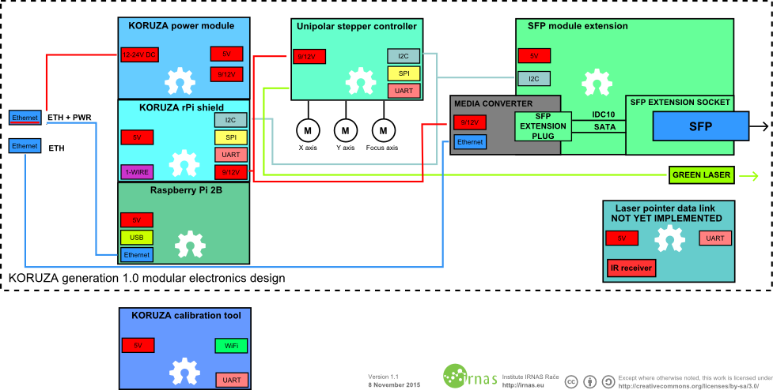

Figure 1: Static Free Space Optical Communication System [1]

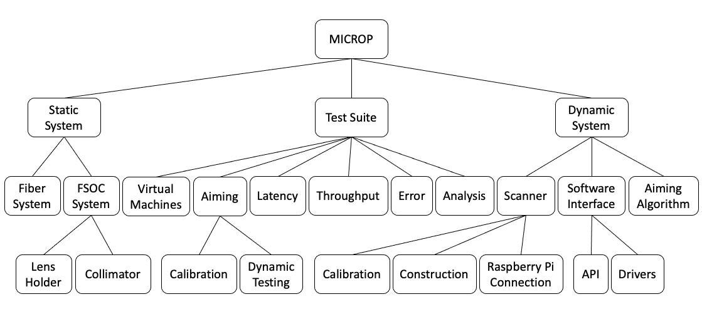

Figure 2: Work Breakdown Structure

[1] <https://github.com/IRNAS/KORUZA/tree/master/diagrams>